Year 9 Geometry (NZC: GM4.5, GM4.6, GM4.8, GM5.5, GM5.6, GM5.7, GM5.8, GM5.9, GM5.10)

**9.9 Use geometry skills when solving problems**

Written by Jake Wills – MathsNZ – [jwills@mathsnz.com](mailto:jwills@mathsnz.com)

|  |  |  |
| --- | --- | --- |
| **Achievement** | **Achievement with Merit** | **Achievement with Excellence** |
| Use geometry skills when solving problems | Use geometry skills, using relational thinking, when solving problems | Use geometry skills, using extended abstract thinking, when solving problems |

Shapes 2

Regular Shapes 2

Triangles 3

Quadrilaterals 3

Solids 4

Isometric Drawing and Side Views 5

Transformation 5

Maps 5

Loci 6

Basic Angle Rules 7

# Shapes

## Regular Shapes

Regular shapes are where all the sides and all the angles are the same.

|  |  |  |
| --- | --- | --- |
| **Shape** | **Name** | **Sides** |
| C:\Users\jakew\AppData\Local\Microsoft\Windows\INetCache\Content.Word\regularshapes-3.png | Triangle | 3 |
| C:\Users\jakew\AppData\Local\Microsoft\Windows\INetCache\Content.Word\regularshapes-4.png | Square | 4 |
| C:\Users\jakew\AppData\Local\Microsoft\Windows\INetCache\Content.Word\regularshapes-5.png | Pentagon | 5 |
| C:\Users\jakew\AppData\Local\Microsoft\Windows\INetCache\Content.Word\regularshapes-6.png | Hexagon | 6 |
| C:\Users\jakew\AppData\Local\Microsoft\Windows\INetCache\Content.Word\regularshapes-7.png | Heptagon | 7 |
| C:\Users\jakew\AppData\Local\Microsoft\Windows\INetCache\Content.Word\regularshapes-8.png | Octagon | 8 |
| C:\Users\jakew\AppData\Local\Microsoft\Windows\INetCache\Content.Word\regularshapes-10.png | Decagon | 10 |
| C:\Users\jakew\AppData\Local\Microsoft\Windows\INetCache\Content.Word\regularshapes-12.png | Dodecagon | 12 |

## Triangles

Triangles are shapes with 3 sides

|  |  |  |
| --- | --- | --- |
| **Triangle** | **Name** | **Properties** |
| C:\Users\jakew\AppData\Local\Microsoft\Windows\INetCache\Content.Word\triangle-regular.png | Equilateral | All sides and angles the same |
| C:\Users\jakew\AppData\Local\Microsoft\Windows\INetCache\Content.Word\triangle-isosceles.png | Isosceles | Two sides and two angles the same |
| C:\Users\jakew\AppData\Local\Microsoft\Windows\INetCache\Content.Word\triangle-scalene.png | Scalene | No sides or angles the same |
| C:\Users\jakew\AppData\Local\Microsoft\Windows\INetCache\Content.Word\triangle-rightangle.png | Right Angle | Has a right angle |

## Quadrilaterals

Quadrilaterals are shapes with 4 sides.

|  |  |  |  |  |  |  |
| --- | --- | --- | --- | --- | --- | --- |
| **Shape** | **Name** | **All sides equal?** | **Two pairs of parallel sides?** | **Adjacent Sides Equal** | **Angles 90 degrees?** | **Opposite Angles Equal** |
| C:\Users\jakew\AppData\Local\Microsoft\Windows\INetCache\Content.Word\quadrilateral-square.png | Square | Yes | Yes | Yes | Yes | Yes |
| C:\Users\jakew\AppData\Local\Microsoft\Windows\INetCache\Content.Word\quadrilateral-trapezium.png | Trapezium | No | No | No | No | No |
| C:\Users\jakew\AppData\Local\Microsoft\Windows\INetCache\Content.Word\quadrilateral-rhombus.png | Rhombus | Yes | Yes | Yes | No | Yes |
| C:\Users\jakew\AppData\Local\Microsoft\Windows\INetCache\Content.Word\quadrilateral-rectangle.png | Rectangle | No | Yes | No | Yes | Yes |
| C:\Users\jakew\AppData\Local\Microsoft\Windows\INetCache\Content.Word\quadrilateral-parallelogram.png | Parallelogram | No | Yes | No | No | Yes |
| C:\Users\jakew\AppData\Local\Microsoft\Windows\INetCache\Content.Word\quadrilateral-kite.png | Kite | No | No | Yes | No | No |

# Solids

|  |  |  |  |  |  |
| --- | --- | --- | --- | --- | --- |
| **Solid** | **Net** | **Name** | **Faces** | **Edges** | **Vertices** |
| C:\Users\jakew\AppData\Local\Microsoft\Windows\INetCache\Content.Word\solid-cylinder.png | C:\Users\jakew\AppData\Local\Microsoft\Windows\INetCache\Content.Word\net-cylinder.png | Cylinder | 3 | 2 | 0 |
| C:\Users\jakew\AppData\Local\Microsoft\Windows\INetCache\Content.Word\solid-triangularprism.png | C:\Users\jakew\AppData\Local\Microsoft\Windows\INetCache\Content.Word\net-triangularprism.png | Triangular Prism | 5 | 9 | 6 |
| C:\Users\jakew\AppData\Local\Microsoft\Windows\INetCache\Content.Word\solid-cube.png | C:\Users\jakew\AppData\Local\Microsoft\Windows\INetCache\Content.Word\net-cube.png | Cube | 6 | 12 | 8 |
| C:\Users\jakew\AppData\Local\Microsoft\Windows\INetCache\Content.Word\solid-rectangularprism.png | C:\Users\jakew\AppData\Local\Microsoft\Windows\INetCache\Content.Word\net-rectangularprism.png | Rectangular Prism (Cuboid) | 6 | 12 | 8 |
| C:\Users\jakew\AppData\Local\Microsoft\Windows\INetCache\Content.Word\solid-pentagonalprism.png | C:\Users\jakew\AppData\Local\Microsoft\Windows\INetCache\Content.Word\net-pentagonalprism.png | Pentagonal Prism | 7 | 15 | 10 |
| C:\Users\jakew\AppData\Local\Microsoft\Windows\INetCache\Content.Word\solid-hexagonalprism.png | C:\Users\jakew\AppData\Local\Microsoft\Windows\INetCache\Content.Word\net-hexagonalprism.png | Hexagonal Prism | 8 | 18 | 12 |
| C:\Users\jakew\AppData\Local\Microsoft\Windows\INetCache\Content.Word\solid-heptagonalprism.png | C:\Users\jakew\AppData\Local\Microsoft\Windows\INetCache\Content.Word\net-heptagonalprism.png | Heptagonal Prism | 9 | 21 | 14 |
| C:\Users\jakew\AppData\Local\Microsoft\Windows\INetCache\Content.Word\solid-octagonalprism.png | C:\Users\jakew\AppData\Local\Microsoft\Windows\INetCache\Content.Word\net-octagonalprism.png | Octagonal Prism | 10 | 24 | 16 |
| C:\Users\jakew\AppData\Local\Microsoft\Windows\INetCache\Content.Word\solid-trianglebasedpyramid.png | C:\Users\jakew\AppData\Local\Microsoft\Windows\INetCache\Content.Word\net-trianglebasedpyramid.png | Triangular Based Pyramid (Tetrahedron) | 4 | 6 | 4 |
| C:\Users\jakew\AppData\Local\Microsoft\Windows\INetCache\Content.Word\solid-squarebasedpyramid.png | C:\Users\jakew\AppData\Local\Microsoft\Windows\INetCache\Content.Word\net-squarebasedpyramid.png | Square Based Pyramid | 5 | 8 | 5 |
| C:\Users\jakew\AppData\Local\Microsoft\Windows\INetCache\Content.Word\solid-pentagonbasedpyramid.png | C:\Users\jakew\AppData\Local\Microsoft\Windows\INetCache\Content.Word\net-pentagonbasedpyramid.png | Pentagonal Based Pyramid | 6 | 10 | 6 |
| C:\Users\jakew\AppData\Local\Microsoft\Windows\INetCache\Content.Word\solid-hexagonbasedpyramid.png | C:\Users\jakew\AppData\Local\Microsoft\Windows\INetCache\Content.Word\net-hexagonbasedpyramid.png | Hexagonal Based Pyramid | 7 | 12 | 7 |

# Isometric Drawing and Side Views

Isometric drawing

* From picture
* From side views

Drawing Side Views

# Transformation

Follow instructions to reflect, rotate, translate, and enlarge (1 step)

**NEED TO DO:** Describe 1 step transformations

# Maps

Map Distances

Compass Directions

Bearings

Grid References

# Loci

A locus (or plural loci) is the set of points that match a certain criteria.

Let’s look at two examples. The first one is all the points that are a certain distance from another point. For this the set of points form a circle, as everywhere on the circle is the same distance from the point. For example:

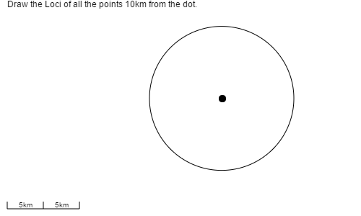

The other type of loci we look at is the points that are all a certain distance from a line. If we look at this dark black line, all the points that form the two lines either side are all the same distance away from the line.

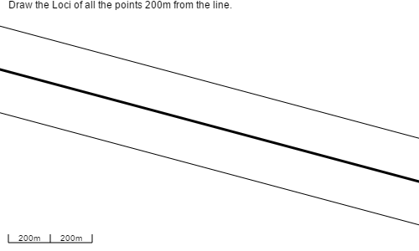

# Basic Angle Rules

**Angles on a line add to 180°**

For example, if one angle is 141° the other one must be 180 – 141 = 39°

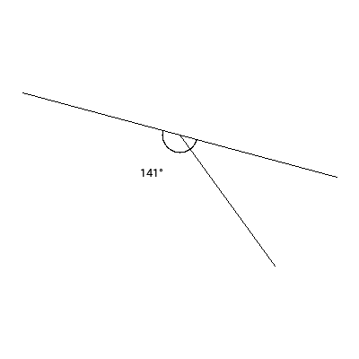

**Angles at a Point at to 360°**

For example, if one of the angles is 222° and another one is 81°,

The final angle must be 360 – 222 – 81 = 57°

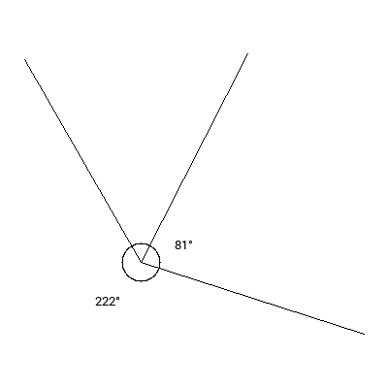

**Angles in a Triangle add to 180°**

For example, if one angle is 57° and another one is 49° the final one must be 180 – 57 – 49 = 74°

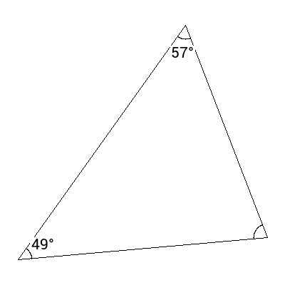

**Vertically Opposite Angles are Equal**

These are angles that are opposite each other on two connecting lines, they are always the same size. For example if one is 45° the angle opposite it will also be 45°

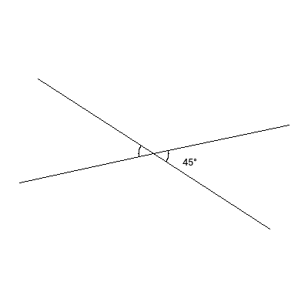

# Teaching Plan

|  |  |  |  |  |
| --- | --- | --- | --- | --- |
| **Week** | **Lesson 1** | **Lesson 2** | **Lesson 3** | **Lesson 4** |
| **1** | Regular Shapes and Triangles | Quadrilaterals | Solids and Nets | Properties of Solids |
| **2** | Isometric Drawing and Side Views | Isometric Drawing from Side Views | Reflection and Translation | Enlargement and Rotation |
| **3** | Angles on a Line and Angles at a Point | Vertically Opposite Angles and Angles in a Triangle | Catch up Day | Give out assessment |
| **4** | Working on assessment | Working on assessment | Working on assessment | Working on assessment |
| **5** | Assessment due in – start next topic |  |  |  |

Note: for this topic we gave out an open ended assignment looking at modular housing and the different layouts that could be formed, linking this to isometric drawing, symmetry and rotation, the costings of these different layouts and students needed to produce an advertising brochure for a suburb based off these modular homes.